**LAB-4**

// start hadoop (must be in hduser)

$ start-all.sh

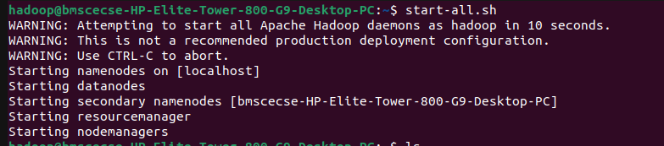

// creating a directory inside hadoop -mkdir

$ hdfs dfs -mkdir /bda_hadoop



// listing all content inside hadoop - ls

$ hadoop fs -ls /



// copyig files from deskop using put command - put

$ hdfs dfs -put /home/hduser/Desktop/bda_local.txt /bda_hadoop/file.txt



// cat command(listing the content of file in hadoop) -cat

$ hdfs dfs -cat /bda_hadoop/file.txt



// copying files from local reference using copyFromLocal cmd.

$ hdfs dfs -copyFromLocal /home/hduser/Desktop/bda_local.txt /bda_hadoop/file_cp_local.txt

$ hdfs dfs -cat /bda_hadoop/file_cp_local.txt



// get command

$ hdfs dfs -get /bda_hadoop/file.txt /home/hduser/Downloads/downloaded_file.txt

$ hdfs dfs -getmerge /bda_hadoop/file.txt /bda_hadoop/file_cp_local.txt /home/hduser/Downloads/downloaded_file.txt



$ hadoop fs -getfacl /bda_hadoop/

# file: /bda_hadoop

# owner: hduser

# group: supergroup

user::rwx

group::r-x

other::r-x

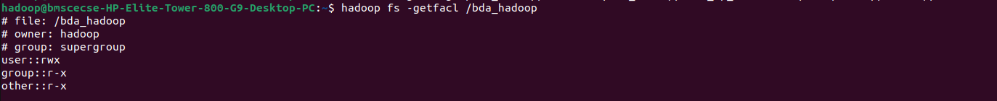

// copyToLocal

$ hdfs dfs -copyToLocal /bda_hadoop/file.txt /home/hduser/Desktop



// mv

$ hadoop fs -mv /bda_hadoop /abc

$ hadoop fs -ls /abc

Found 1 items

drwxr-xr-x - hduser supergroup 0 2022-06-06 11:52 /abc/bda_hadoop

// copy

$ hadoop fs -cp /abc/ /hadoop_lab



